**­­­­Customer Journey Map:**

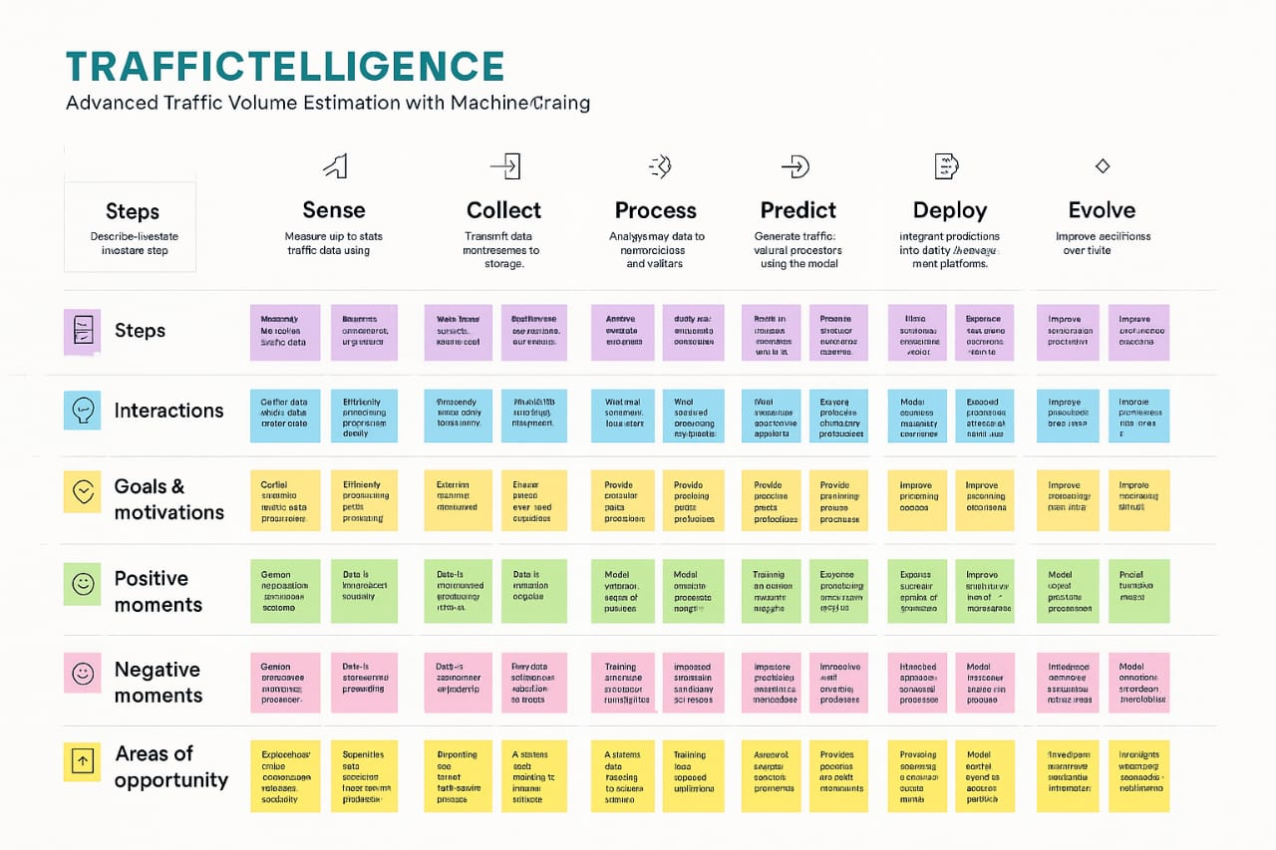

**🧠 Customer Journey for Traffic Intelligence Estimation Using Machine Learning**

**Introduction**

Traffic congestion is a growing challenge in urban areas. Machine learning (ML) offers a powerful solution by analyzing vast amounts of traffic data to provide real-time insights, predict congestion, and optimize traffic flow. This customer journey map outlines the stages a user (e.g., a city planner or traffic authority) experiences when adopting and using an ML-based traffic intelligence system.

**1. Awareness Stage**

* **Customer Actions**: Learns about traffic estimation solutions through online research, webinars, or industry events.
* **Customer Needs**: Understand the benefits of ML in traffic management.
* **ML Opportunities**: Share success stories, demo predictive models, and highlight cost savings.

**2. Consideration Stage**

* **Customer Actions**: Compares different vendors, requests demos, evaluates features and pricing.
* **Customer Needs**: Accuracy, scalability, integration with existing infrastructure.
* **ML Opportunities**: Provide interactive dashboards, sample predictions, and ROI calculators.

**3. Onboarding Stage**

* **Customer Actions**: Signs agreement, shares historical traffic data, defines KPIs.
* **Customer Needs**: Smooth integration, data privacy, and clear onboarding process.
* **ML Opportunities**: Automate data ingestion, customize models based on local patterns.

**4. Implementation Stage**

* **Customer Actions**: Connects sensors, cameras, and GPS data to the system.
* **Customer Needs**: Reliable data flow, minimal downtime, technical support.
* **ML Opportunities**: Real-time anomaly detection, model tuning based on live data.

**5. Usage Stage**

* **Customer Actions**: Monitors traffic, receives alerts, uses insights for planning.
* **Customer Needs**: Actionable insights, user-friendly interface, mobile access.
* **ML Opportunities**: Predictive heatmaps, congestion alerts, adaptive signal control.

**6. Optimization Stage**

* **Customer Actions**: Refines strategies, provides feedback, requests new features.
* **Customer Needs**: Continuous improvement, higher accuracy, better performance.
* **ML Opportunities**: Retrain models with feedback, introduce new data sources (e.g., weather, events).

**7. Advocacy Stage**

* **Customer Actions**: Shares results with stakeholders, recommends the solution.
* **Customer Needs**: Recognition, proof of success, community engagement.
* **ML Opportunities**: Publish case studies, offer data-sharing incentives, build user community.

**Conclusion**

Machine learning transforms traffic management by enabling smarter, data-driven decisions. Mapping the customer journey helps identify where ML adds the most value and ensures a seamless experience from discovery to advocacy.